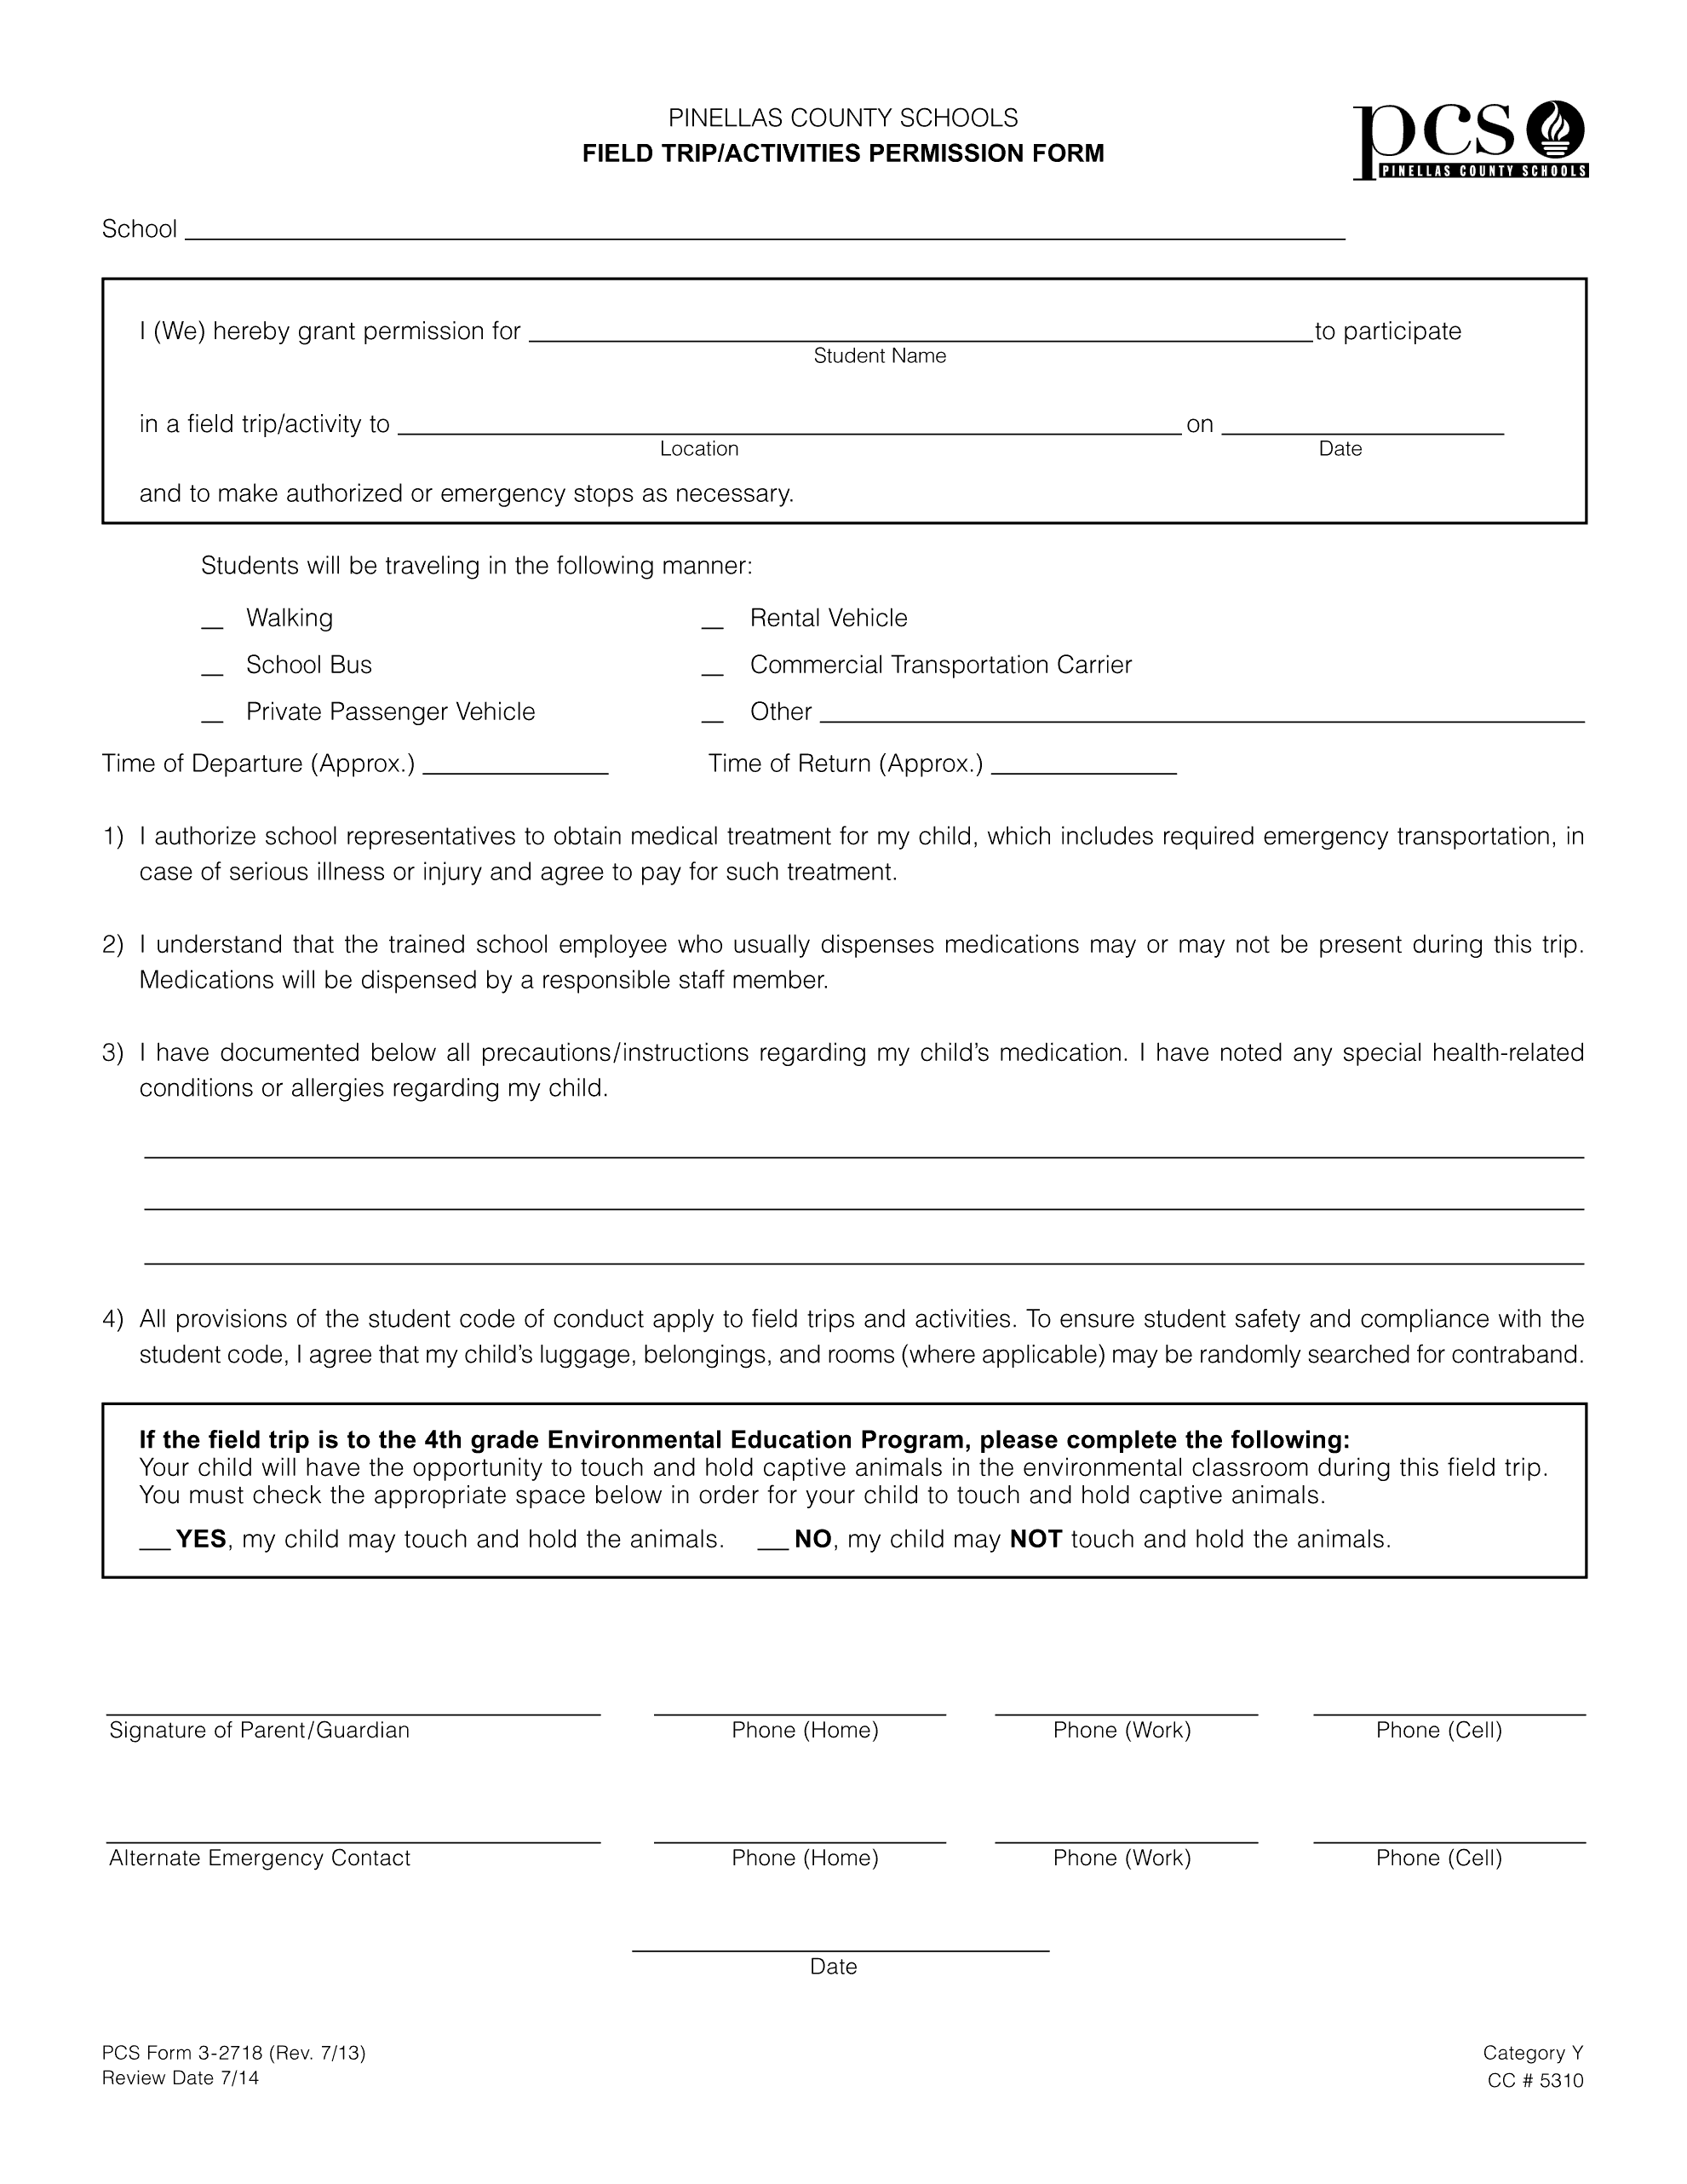

PERKINS ELEMENTARY SCHOOL

X MUST SEND EXACT CHANGE OR CHECK/MONEY ORDER

‘

